**Section -4- Equipment & Others:**

**1.33/11kV VCB (Vacuum Circuit breaker):**

A **33/11kV Vacuum Circuit Breaker (VCB)** is used in medium-voltage substations for switching and protection. It's essential in power distribution between high voltage (33kV) and medium voltage (11kV) networks. Here are the **key features** of a 33/11kV VCB:

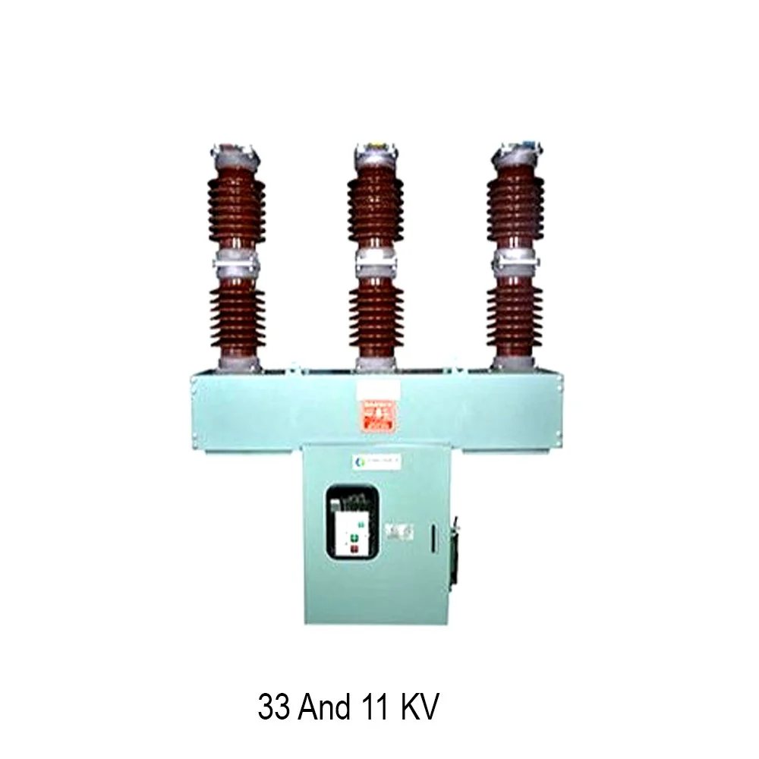

**🔧 Technical & Operational Features**

* **Voltage Rating:** 33kV (primary) / 11kV (secondary)
* **Breaking Medium:** **Vacuum** – ensures arc quenching in a sealed environment, with minimal wear.
* **Insulation Medium:** Usually **air** or **solid insulation**.
* **Interrupting Capacity:** Typically rated for **16kA to 31.5kA**, depending on design.
* **Rated Current:** Commonly **630A to 1250A**.
* **Operating Mechanism:** **Spring-charged** or **motor-operated** for remote/automatic operations.

**2. 11kV LBS (Load Break Switch) Panel:**

An **11kV LBS (Load Break Switch) Panel** is a crucial part of medium-voltage power distribution systems. It's used for switching under **normal load conditions**, not for fault interruption (unlike circuit breakers). These panels are widely used in **ring main units (RMUs)**, **distribution substations**, and **industrial setups**.

Here’s a breakdown of the **key features and functions** of an **11kV LBS Panel**:

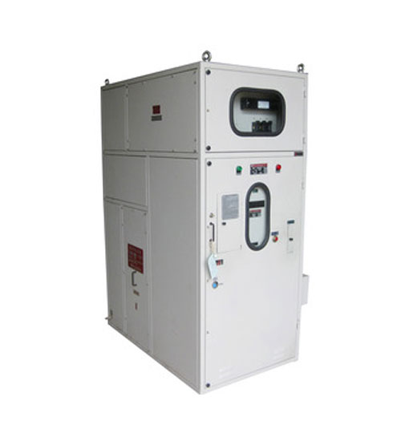

### 🔑 ****11kV Load Break Switch – Key Features****

#### ⚡ **Electrical Ratings**

* **Rated Voltage:** 11kV (typically up to 12kV)
* **Rated Current:** 400A to 630A (commonly used)
* **Short Circuit Withstand:** ~16kA for 3 seconds (depends on design)
* **Frequency:** 50 Hz standard

**3. 33/11kV GIS Switchgear**

**33/11kV GIS (Gas Insulated Switchgear) switchgear** is used in medium-voltage to high-voltage electrical distribution systems, particularly where space is a constraint or high reliability is essential (like in urban substations, industrial plants, and renewable energy applications). Here are the **key features** of 33/11kV GIS switchgear:

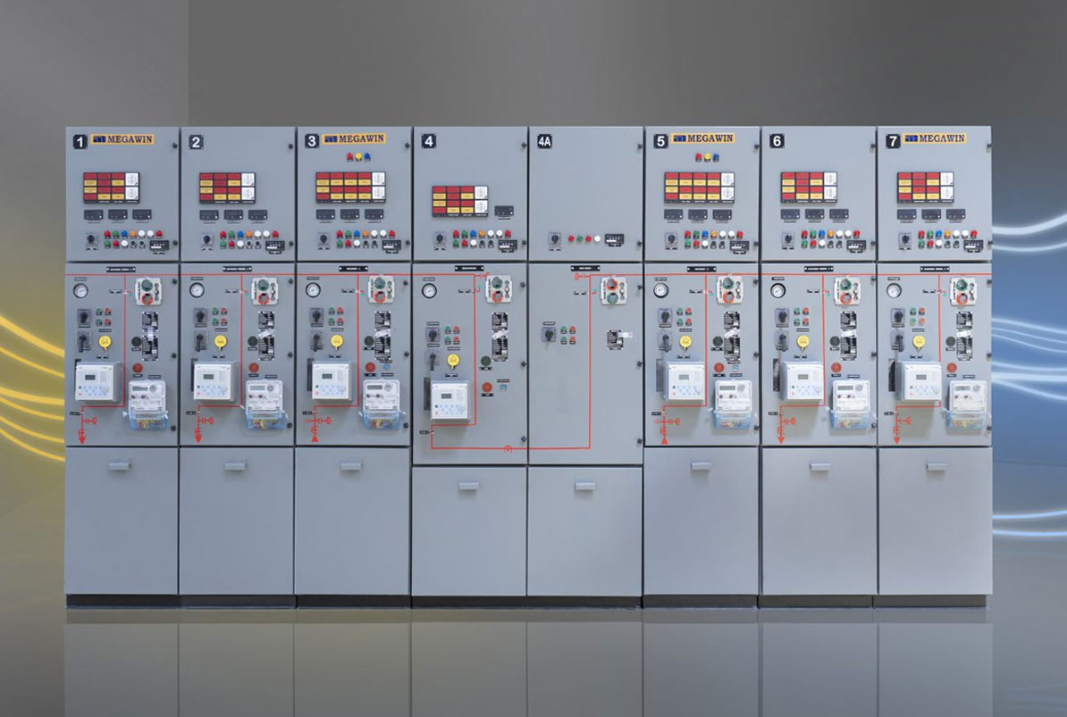

### 🔑 ****Key Features of 33/11kV GIS Switchgear****

#### 1. **Compact Design**

* Enclosed in a metal housing filled with SF₆ gas, which allows for a **much smaller footprint** than conventional air-insulated switchgear (AIS).

#### 2. **High Reliability & Safety**

* SF₆ gas provides excellent **dielectric strength and arc-quenching** capabilities.
* Fully enclosed system minimizes risk of **flashovers, faults, and accidental contact**.

#### 3. **Low Maintenance**

* **Sealed for life** design: most components are maintenance-free over their service life.

#### 4. **High Operational Flexibility**

* Can be configured as **single busbar, double busbar, ring main unit (RMU)**, etc.

#### 5. **Enhanced Monitoring & Control**

* Equipped with **intelligent electronic devices (IEDs)** for automation, SCADA compatibility, and remote operation.

#### 6. **Environmental & Arc Protection**

* SF₆ gas is a potent greenhouse gas, but modern GIS systems have **low leakage rates** and strict containment measures.

#### 7. **Long Service Life**

* Typical lifespan: **30+ years** with minimal degradation.

#### 8. **Short Installation Time**

* Factory-assembled and pre-tested units reduce on-site installation and commissioning time.

#### 9. **High-Level Standards Compliance**

* Designed to meet international standards like **IEC 62271-203**, **IEC 60694**, and others.

**4. 33kV/11kV Current Transformer (CT)**

A **33kV/11kV Current Transformer (CT)** is used in high-voltage power distribution systems to step down current levels from 33kV to 11kV systems for measurement, protection, and control. Here are the **key features** of a typical **33kV/11kV CT**:

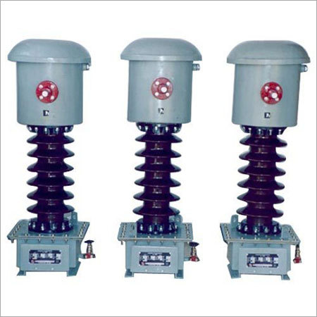

### 🔑 ****Key Features of 33kV/11kV CT:****

#### 1. **Voltage Rating**

* Primary voltage: 33kV
* Secondary voltage: 11kV

#### 2. **Current Ratio**

* Typical ratios: 100/1 A, 200/1 A, 400/5 A, etc.
* Customized ratios available based on system requirements.

**5. 33kV/11kV Potential Transformer (PT)**

Here are the 🔑 **Key Features of a 33kV/11kV Potential Transformer (PT)**, also known as a **Voltage Transformer (VT)**, which is used for voltage measurement and protection in high-voltage systems:

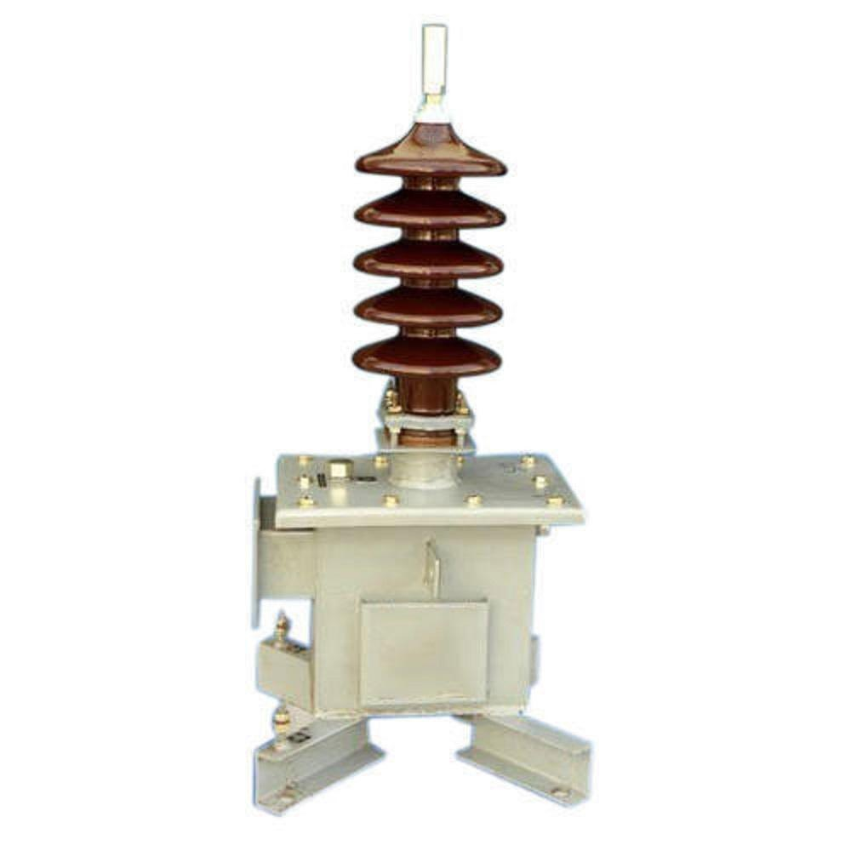

**🔑 Key Features of 33kV/11kV PT (Potential Transformer)**

| **Feature** | **Description** |
| --- | --- |
| **Primary Voltage** | 33kV |
| **Secondary Voltage** | 110V / 115V (standard for metering and protection systems) |
| **Accuracy Class** | Class 0.2, 0.5 (metering) / Class 3P, 6P (protection) |
| **Burden** | 10 VA, 15 VA, 30 VA or as specified |
| **Construction Type** | Resin cast (indoor) / Oil-filled or SF6 (outdoor) |
| **Insulation Level (BIL)** | Up to 170kV impulse withstand, 70kV power frequency withstand |
| **Frequency** | 50Hz / 60Hz |
| **Standards Compliance** | IEC 61869-3 / IS 3156 / ANSI C57 |
| **Mounting** | Pole-mounted / Panel-mounted / Base-mounted |
| **Safety Features** | Earth terminals, fused secondary (optional), test links |
| **Applications** | Used for voltage measurement, protection, SCADA systems in substations |

**6. 33/11kV Disconnecting Switch**

A 33/11kV disconnecting switch (also known as an isolator switch) is a high-voltage switch used to ensure that an electrical circuit is completely de-energized for maintenance or service. These switches are crucial components in substations and distribution systems. Here are the key features of a typical 33/11kV disconnecting switch

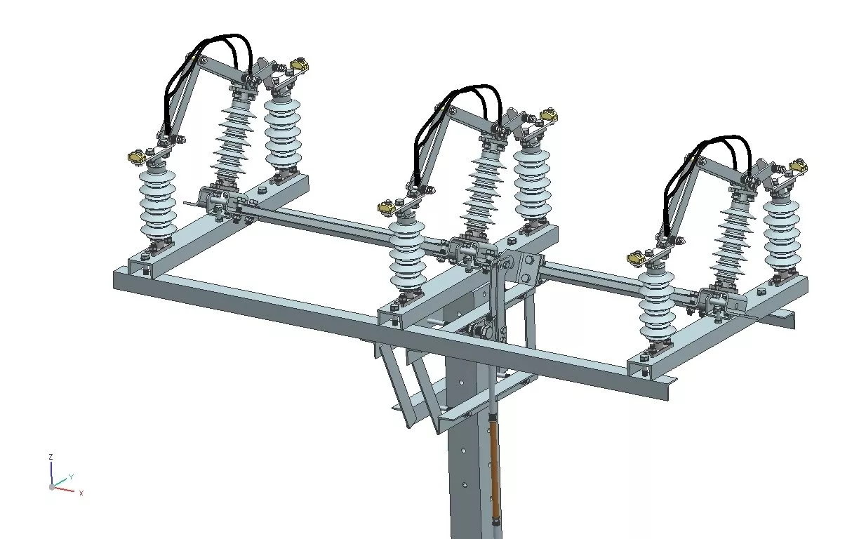

### 🔌 ****33/11kV Disconnecting Switch – Key Features****

#### 1. **Voltage & Current Ratings**

* **Nominal Voltage**: 33kV / 11kV
* **Rated Current**: 400A to 1600A (varies by application)
* **Short-Time Withstand Current**: Typically 16kA to 31.5kA for 1-3 seconds

#### 2. **Type of Switch**

* **Off-load switch**: Operated when the line is de-energized (not designed for breaking load current)
* **Types**: Single-break, Double-break, or Centre-break depending on design needs

**7.** Air Circuit Breakers (ACBs) rated up to **6300A**

Air Circuit Breakers (ACBs) rated up to **6300A** are high-capacity circuit breakers typically used in industrial and commercial power systems for **protection, isolation, and control** of electrical circuits. Here are the **key features** of ACBs up to 6300A:

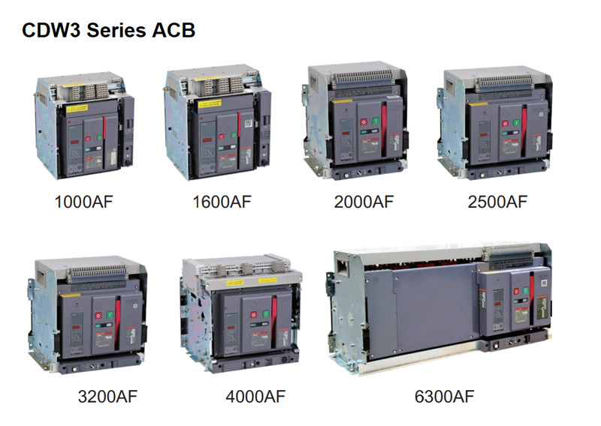

### 🔌 ****Electrical Ratings****

* **Rated current (In):** Up to **6300A**
* **Rated voltage (Ue):** Typically **690V AC** (can vary)
* **Breaking capacity (Icu/Ics):** Can range from **50kA to 150kA or higher**, depending on the model

**8.** MCCB (Molded Case Circuit Breaker) rated up to **1600A**

An MCCB (Molded Case Circuit Breaker) rated up to **1600A** is a type of electrical protection device used to protect circuits from **overload**, **short circuits**, and **earth faults** in **low voltage power distribution systems**.

Here's a quick rundown of MCCBs up to 1600A:

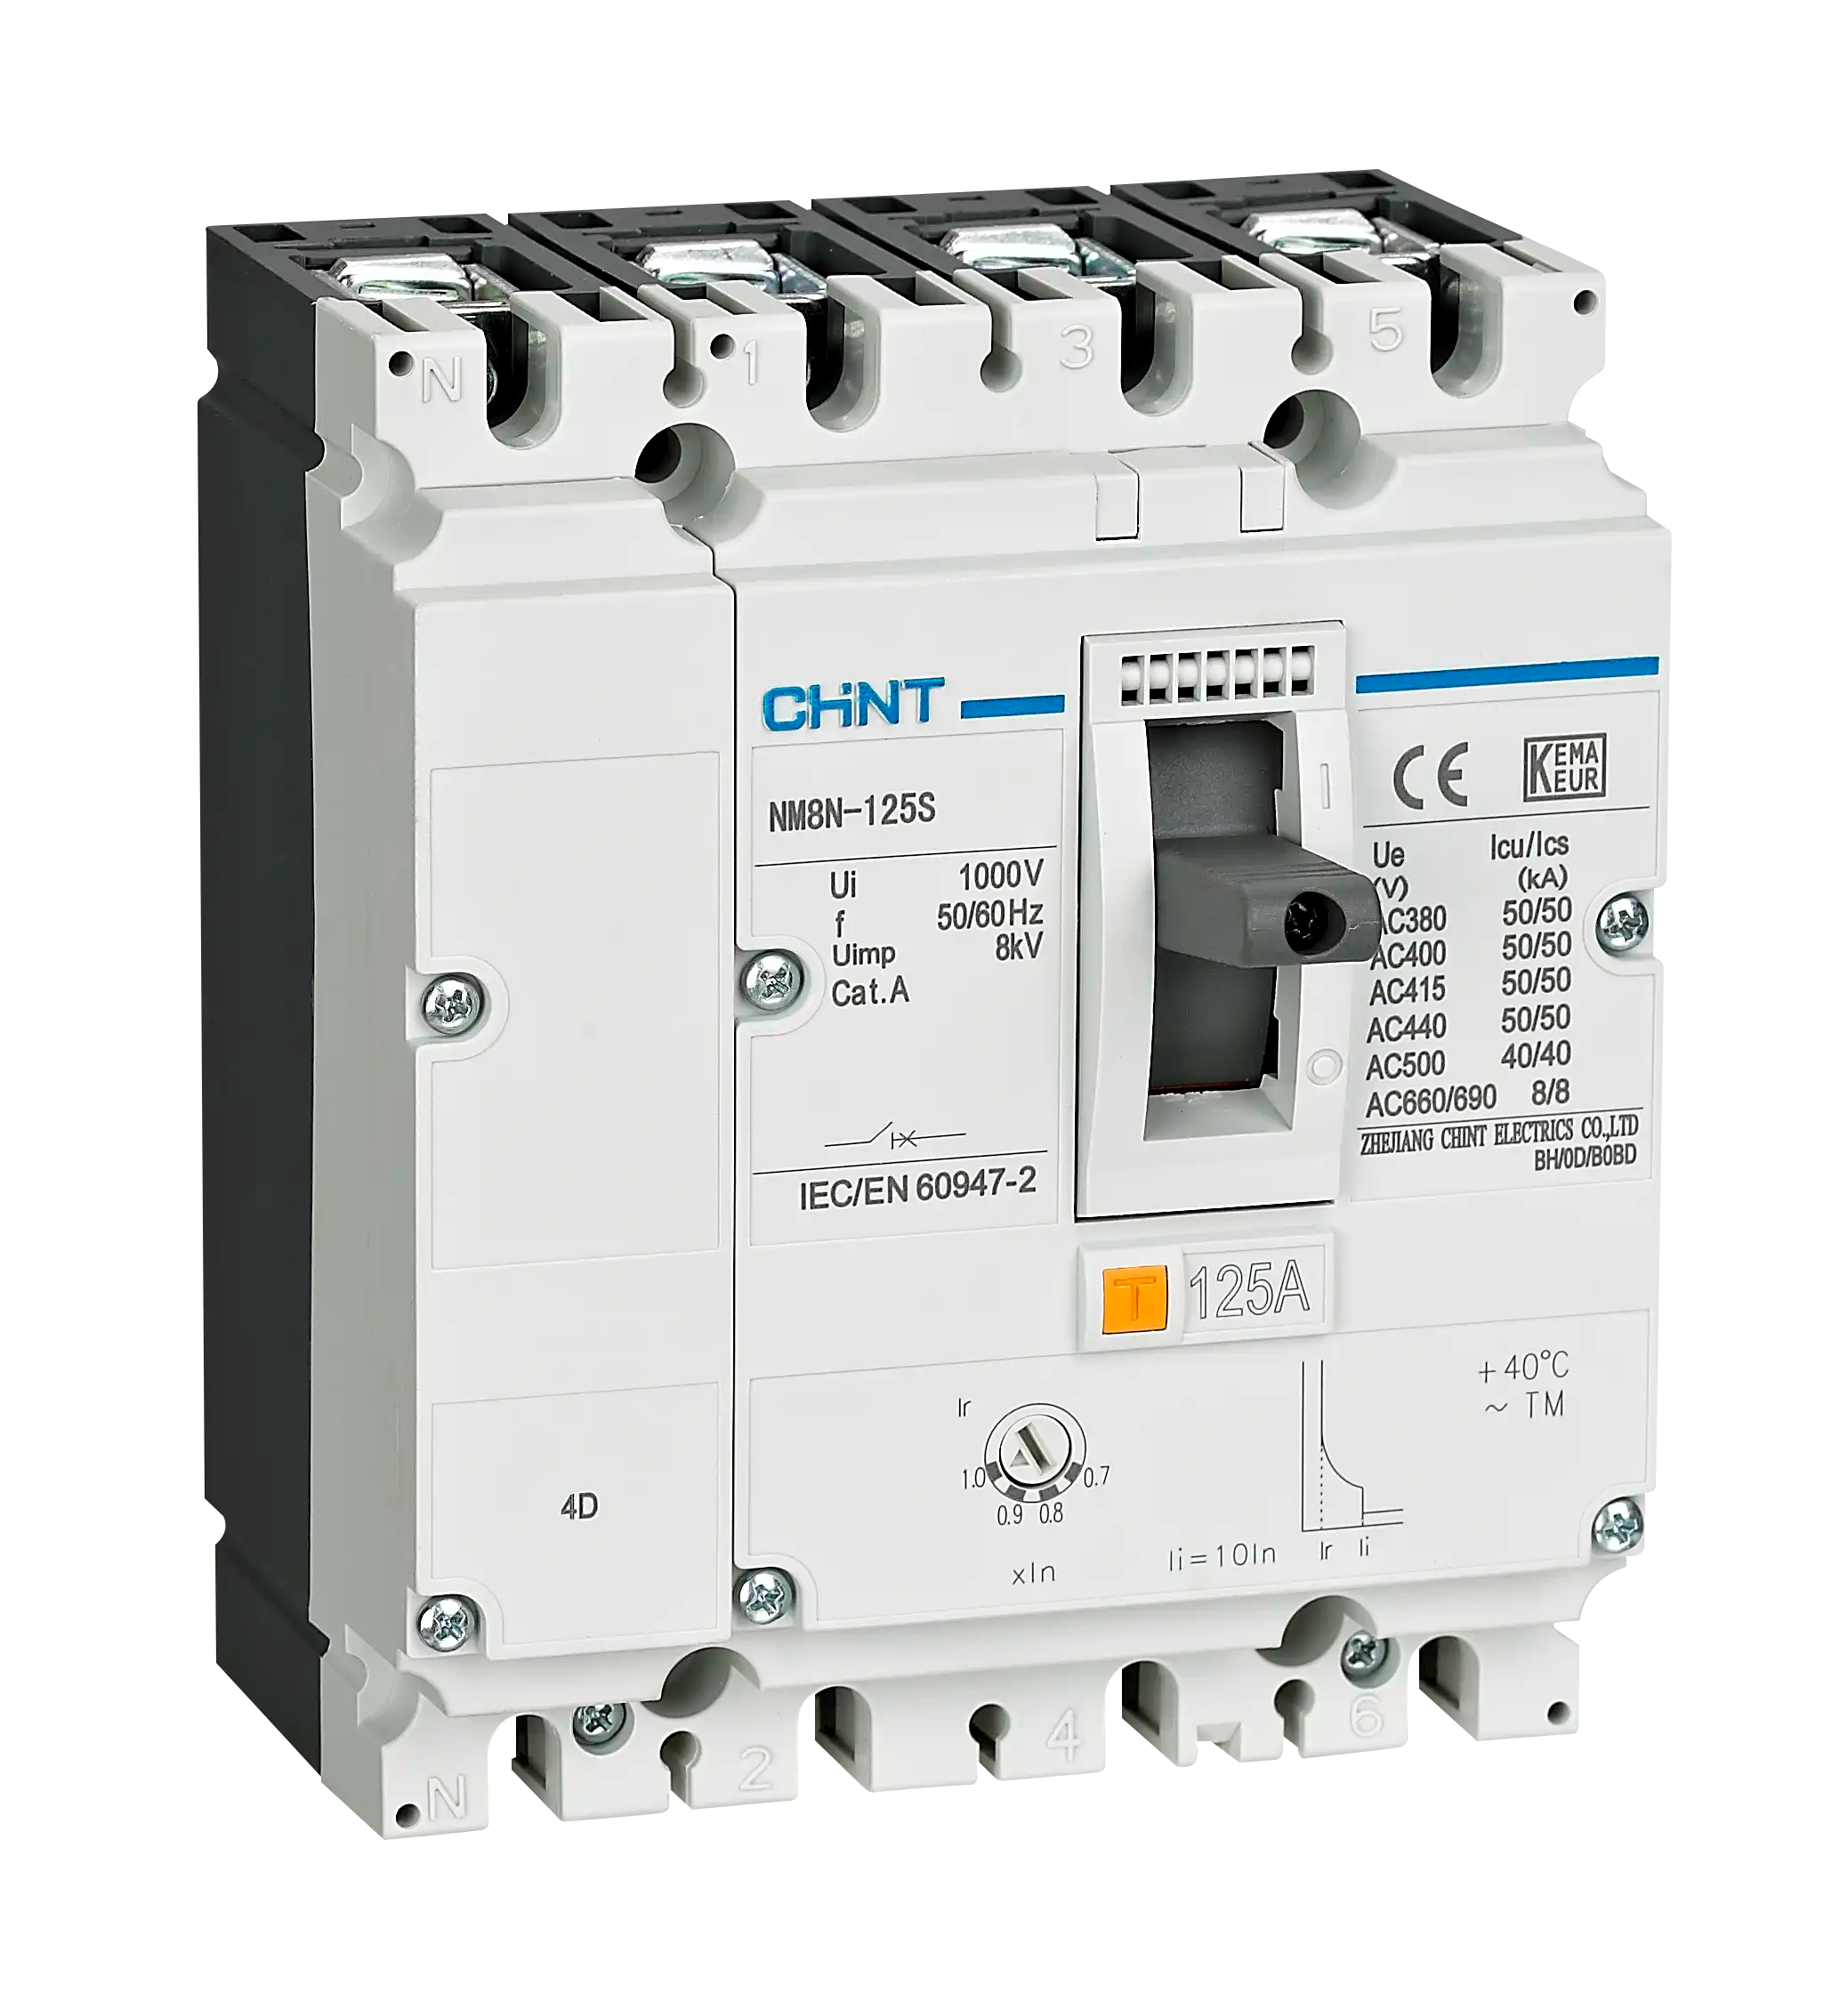

### 🔧 ****Basic Specifications (Typical for MCCBs up to 1600A):****

* **Current Rating (In):** From around 100A to 1600A
* **Breaking Capacity (Icu/Ics):** Varies, e.g. 36kA, 50kA, 65kA, 85kA, or even 100kA at 415V AC
* **Number of Poles:** 3P or 4P
* **Rated Voltage (Ue):** Typically 415V AC (can be higher depending on the brand)
* **Rated Insulation Voltage (Ui):** Often up to 1000V
* **Trip Mechanism:**
  + Thermal-magnetic (for basic applications)
  + Electronic (for adjustable and advanced protection)

**9. P (Triple Pole)**, **DP (Double Pole)**, and **SP (Single Pole)** **MCBs (Miniature Circuit Breakers)**:

Here's a concise breakdown of the key features for **TP (Triple Pole)**, **DP (Double Pole)**, and **SP (Single Pole)** **MCBs (Miniature Circuit Breakers)**:

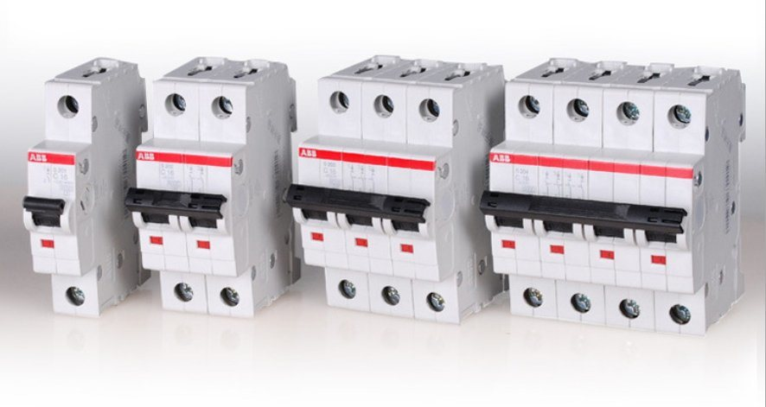

### 🔌 ****SP (Single Pole) MCB****

* **Poles:** 1 (connects only the phase wire)
* **Usage:** Single-phase circuits
* **Voltage Rating:** Typically 230V AC
* **Key Features:**
  + Protects only one live conductor
  + Common in residential wiring
  + Compact and space-saving
  + Provides short-circuit and overload protection

### ⚡ ****DP (Double Pole) MCB****

* **Poles:** 2 (disconnects both phase and neutral)
* **Usage:** Single-phase circuits with neutral disconnection
* **Voltage Rating:** 230V/240V AC
* **Key Features:**
  + Simultaneous disconnection of phase and neutral
  + Enhances safety during faults
  + Ideal for appliances requiring full isolation

### 🔋 ****TP (Triple Pole) MCB****

* **Poles:** 3 (for all three phases – R, Y, B)
* **Usage:** Three-phase systems
* **Voltage Rating:** 400V AC
* **Key Features:**
  + Disconnects all three phases simultaneously
  + Used in commercial/industrial setups
  + Protects motors, machinery, HVAC systems
  + No neutral disconnection

**10. 11kV Capacitor**

Here are the **key features** of an **11kV capacitor**, typically used in power factor correction and reactive power compensation in medium-voltage electrical networks:

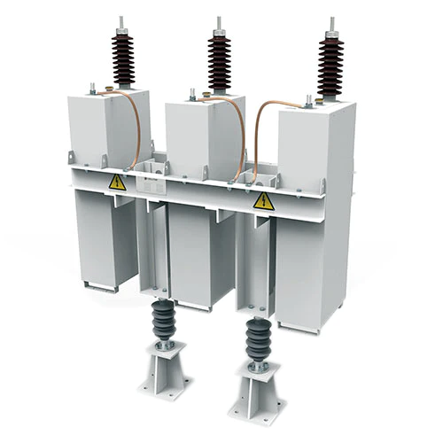

### ⚡ ****Key Features of 11kV Capacitor Banks****

1. **Rated Voltage:**
   * Designed for systems with **11kV (11,000 Volts)** operating voltage.
   * Withstands overvoltage and transient conditions.
2. **Capacitance Rating:**
   * Typically ranges from **50 kVAR to several MVAR**.
   * Available in single or multiple units to achieve desired reactive power.

**11. Low voltage Stabilizer upto 1250kVA.**

Here are the **key features** of a **Low Voltage Stabilizer** (also known as an Automatic Voltage Regulator or AVR) **up to 1250 kVA** capacity:

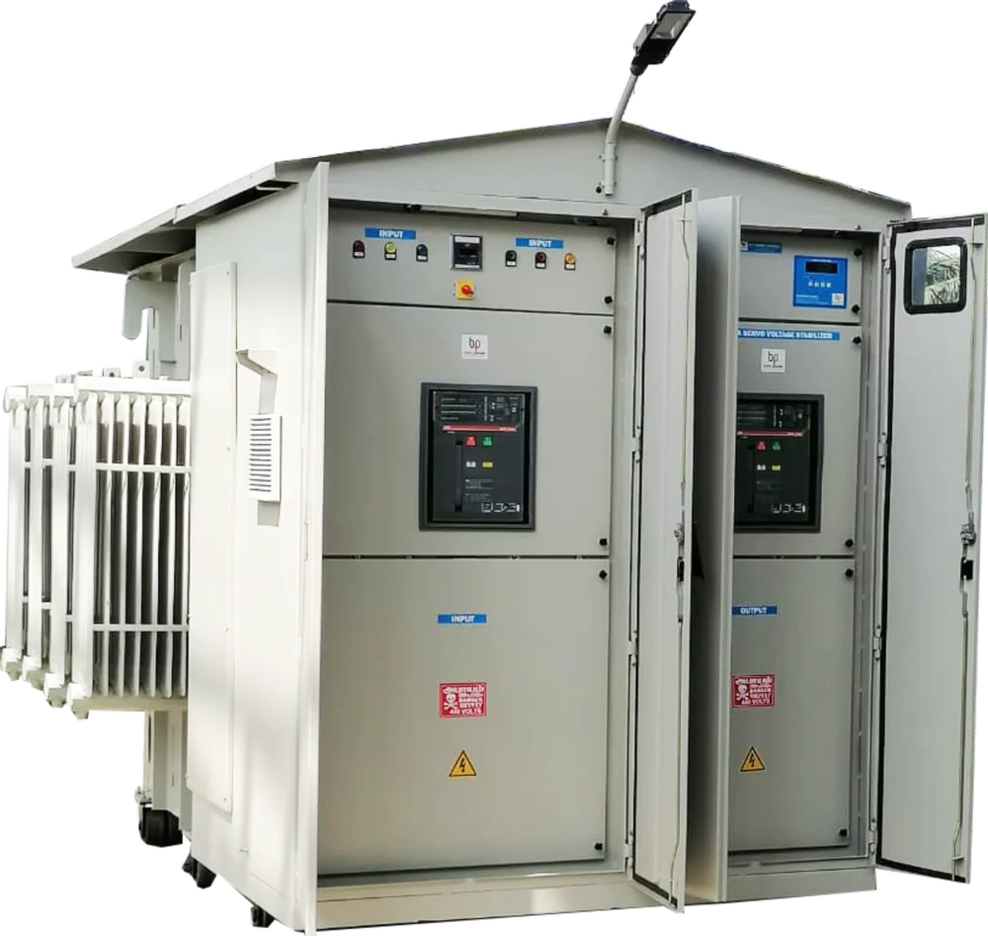

### 🔧 ****Technical Features****

* **Capacity**: Up to 1250 kVA
* **Input Voltage Range**: Typically from **±15% to ±40%** (e.g., 340V–460V for 3-phase)
* **Output Voltage**: Stabilized at **400V ±1% or ±2%** (for 3-phase systems)
* **Correction Speed**: Around **10–40 ms per volt**, depending on model
* **Frequency**: 50/60 Hz compatible

**12.**  **Early Streamer Emission (ESE) Lightning Protection System & Earthing System. (Chemical and Genera**

Here’s a detailed breakdown of **Early Streamer Emission (ESE) Lightning Protection System** and the **Earthing System**, focusing on **chemical and general key features**:

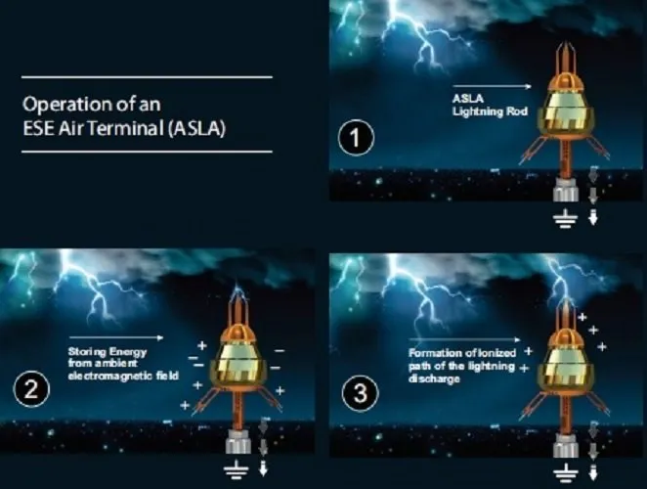

## ⚡️ Early Streamer Emission (ESE) Lightning Protection System

### 🔑 ****General Key Features:****

1. **Advanced Technology**:
   * ESE systems use a proactive method to intercept lightning strikes earlier than conventional lightning rods.
   * They emit an upward streamer before a downward leader can reach ground level, increasing protection radius.
2. **Extended Protection Radius**:
   * A single ESE air terminal can cover a larger area (up to 120 meters radius) depending on its efficiency and height.
   * Suitable for wide area protection: buildings, industrial plants, open grounds.
3. **Time Advance Mechanism (ΔT)**:
   * Refers to how much earlier the ESE terminal emits a streamer compared to a standard rod.
   * Common values range from 10 µs to 60 µs.
4. **Stainless Steel or Copper Alloy Construction**:
   * Corrosion-resistant and highly conductive.
   * Ensures long life even in harsh environmental conditions.
5. **Compliance Standards**:
   * Typically tested and certified according to **NF C 17-102**, **UNE 21186**, or **IEC 62305** standards.
6. **Low Maintenance**:
   * Once installed, ESE systems require minimal maintenance.
   * Periodic inspection is enough to ensure reliability.

## 🌍 Earthing System

Earthing is crucial for dissipating lightning energy safely into the ground.

### 🔑 ****General Key Features:****

1. **Low Resistance Path**:
   * Provides a path of least resistance for lightning and fault currents to dissipate into the earth.
2. **Earth Resistance Value**:
   * Ideally less than **1 ohm** for effective lightning protection.
3. **Types of Earth Electrodes**:
   * Rods (copper bonded), plates, strips, or ring earth systems depending on soil condition and layout.
4. **Soil Resistivity Dependent Design**:
   * Earth pit design is adjusted based on the local soil’s conductivity and moisture.
5. **Surge Protection Devices (SPD)**:
   * Often integrated into the system to protect internal electrical systems.

## ⚗️ Chemical Earthing – Key Features:

Chemical earthing uses a backfill compound that improves conductivity and maintains low resistance over time.

### 🔑 ****Key Features:****

1. **Permanent Low Resistance**:
   * Special compounds (bentonite, graphite, or conductive gel) maintain consistent resistance in all seasons.
2. **Moisture Retention**:
   * Chemically treated earth electrodes absorb and retain moisture, enhancing conductivity even in dry soil.
3. **Longer Life Span**:
   * Less corrosion due to protective coatings and materials used.
4. **No Need for Frequent Watering**:
   * Ideal for remote or dry areas where regular maintenance is difficult.
5. **Environment Friendly**:
   * Non-toxic compounds used in modern chemical earthing prevent soil pollution.
6. **Ready-to-Use Kits**:
   * Most systems come as pre-packaged kits with rod, compound, and accessories for easy installation.